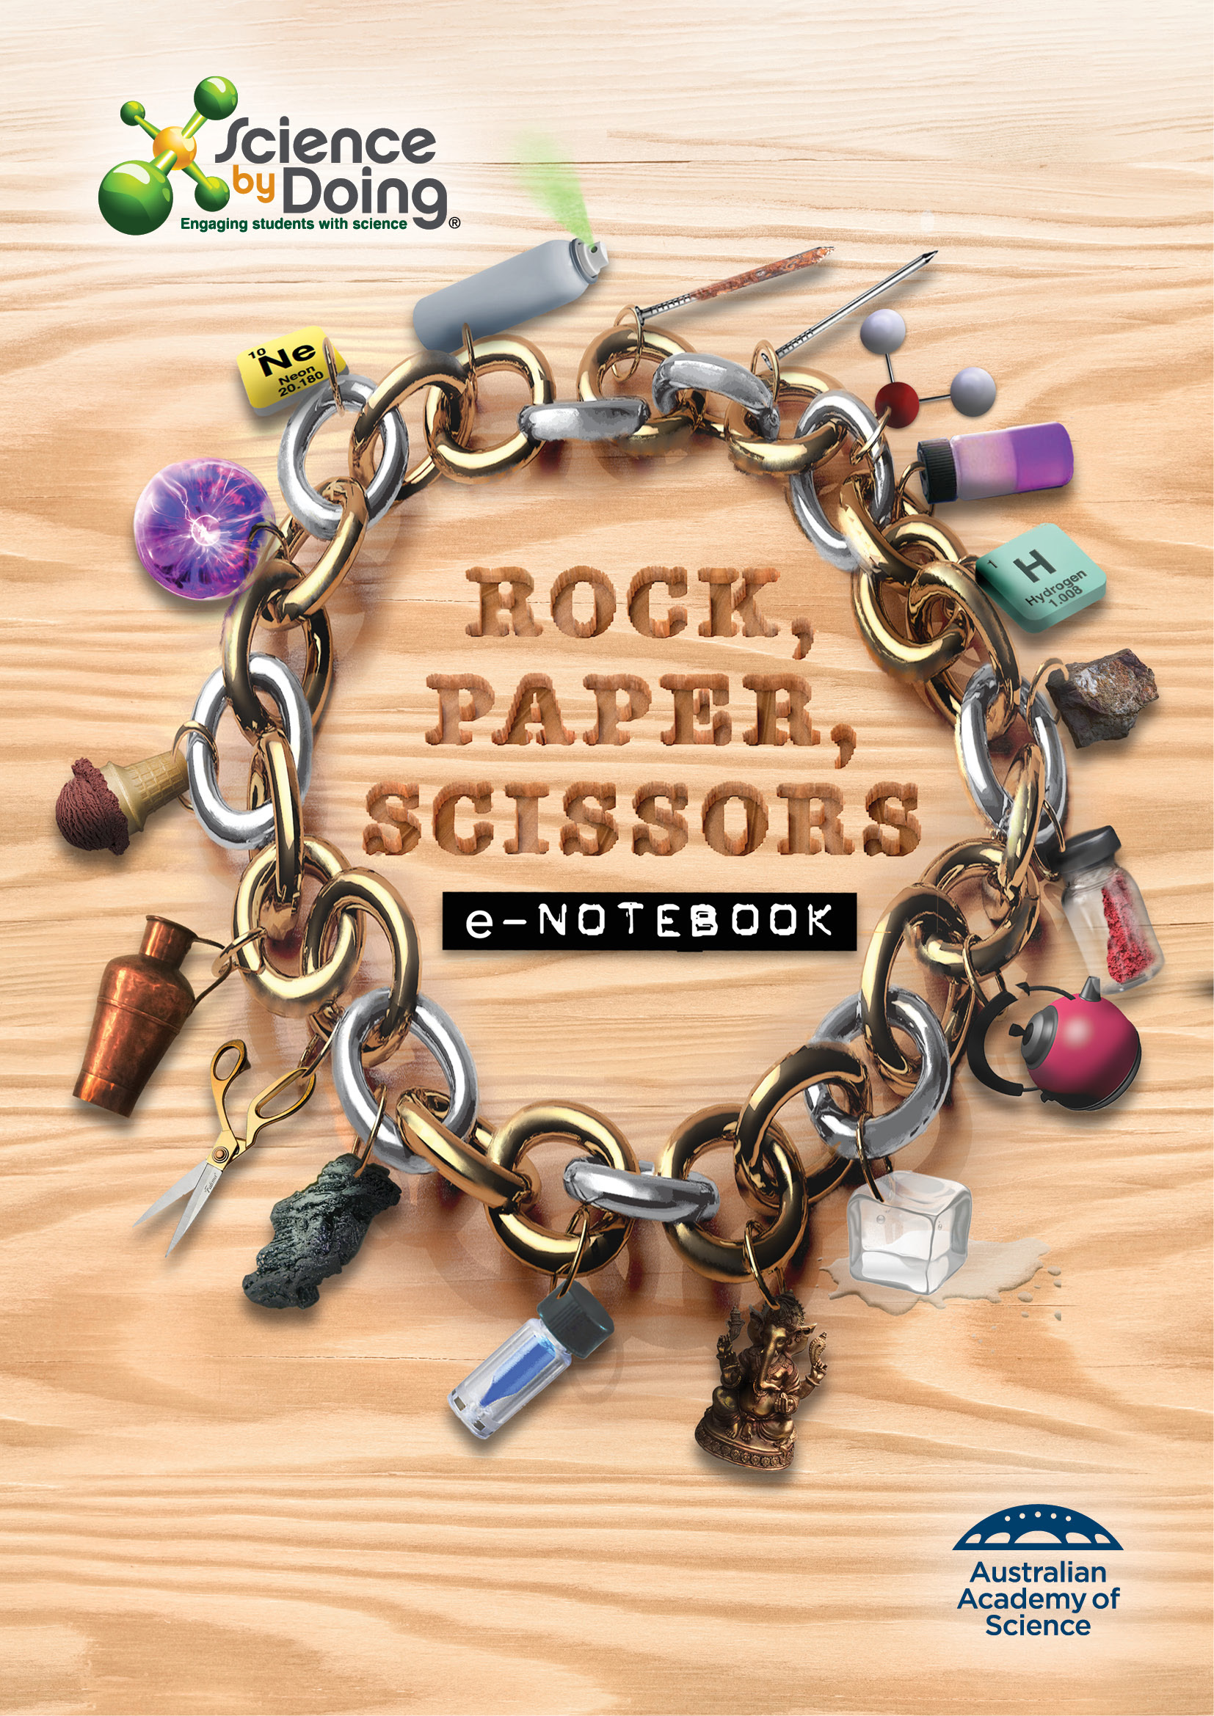
User Guide

Word for PCs
For ease of navigation we suggest you turn on the Navigation Pane located under the View tab in the menu bar.
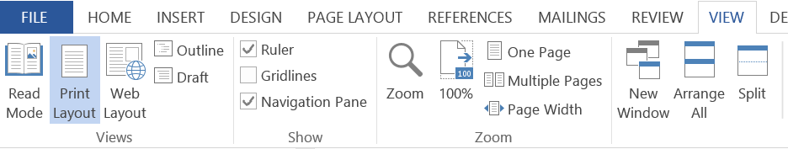

Word for Mac
For ease of navigation we suggest you turn on the Document Map Pane located under the View tab in the menu bar. Select the View tab, select Sidebar then Document Map pane.

This will open up a clickable Navigation column on the left hand side of the document.

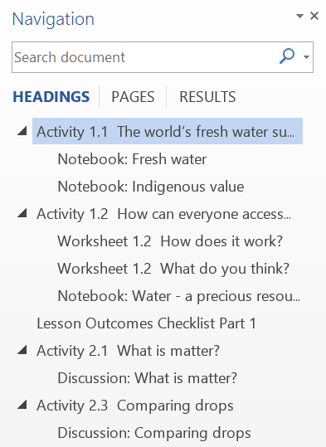

You can select the various elements of each Activity and move through the document with greater ease.

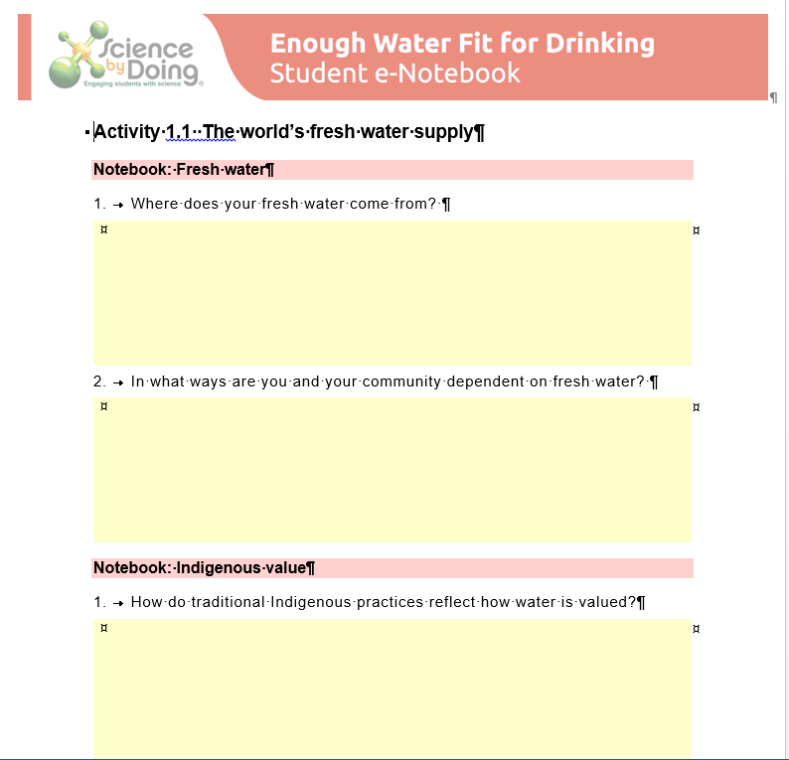

Activity 1.1 It’s a material world

Rock, Paper, Scissors game
Which hand do you think would win in each image? For each image identify what property is featured in the winning hand.
1.
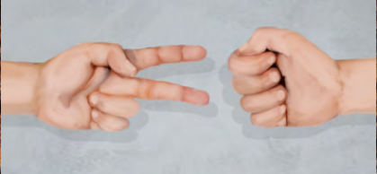
2.
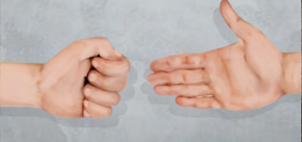

3.
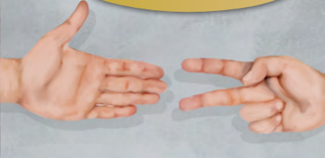

Materials around you
In the table list five materials you see around you. Next to each material write down where and how it is being used.
Material | Use

Select one material from the above table and write down the properties that make it useful for its task.

What are some other uses for this material?

Notebook: Laboratory Safety
Watch each of the videos and answer the following questions.
Safety dress
1. Why do you need to wear closed shoes?

2. Why do you sometimes need to wear safety glasses
3. What precaution do you need to take if you have long hair?

Lab glassware
1. Why do you use a measuring cylinder rather than a beaker to measure volumes?
2. Why do you use a conical flask rather than a beaker to carry out some chemical reactions?

Safety flame
1. Which colour flame is the hottest on a Bunsen burner?
2. What makes the ‘safety flame’ safer?

3. For the safety flame is the air hole open or closed?

Activity 1.2 What is the property?
For each collection of materials list the properties that they all share.
Collection 1
Collection 2
Collection 3
Collection 4

Collection 5
Collection 6
Now that you have identified some properties that can be used to classify different materials, summarise them in this table.
Property | Description | Examples
What have you learnt? Identify the property represented by each group of materials in the previous activity.

Activity 1.3 Metals and their properties
What to do
Step 1 - Carefully observe the samples of metals and non-metals.
Step 2 - Test each sample using some of the tests you learnt about in Activity 1.2. Include a test of whether the sample conducts electricity.
Step 3 - Record your observations in the tables below.
Metals
Properties | Sample 1 | Sample 2 | Sample 3
Colour
Lustre
Malleability
Conductivity
Hardness/strength
Non-Metals
Properties | Sample 1 | Sample 2 | Sample 3
Colour
Lustre
Malleability
Conductivity
Hardness/strength

Discussion
1. Which group (metals or non-metals) had properties that were most similar?

2. Describe some of the properties that you think make metals very useful to us.

How do metals feature in modern life?
Record all the places in the everyday scene in the Student Guide where metals are used.
For each example identify the type of metal and why it is used.
Make a list of ways that our lives have changed due to the use of metals. (Hint: compare your answers above with the ‘stone age’ scene shown on the same page.

Notebook: Metals or non-metals
1. Draw separate Concept Maps for a metal (not iron) and two non-metals prominent in your daily life. Don’t forget to include properties, where the element is found in its natural state and your daily life.
2. Prepare your group’s response to one of the following statements:
Properties are key to a metal’s value
OR
Metals are more useful than non-metals.

Activity 1.4 Rock to scissors

Notebook: Properties and uses of iron
In a group of four, use the digital resources to find five interesting facts about iron.
1. What are the properties of iron?
2. What are some uses of iron?
3. Draw a Concept Map which summarises what you know about iron so far.
4. What do you think would happen if our iron sources ran out?

5. Which element has similar properties and household uses as iron?
6. Research how a Swiss army knife or pair of scissors is made. Discuss with your group how manufacturing has changed and the resulting impact on how we live.

Lesson Outcomes Checklist Part 1
NAME:
ACTIVITY | LESSON OUTCOMES  At the end of these activities I can: | Please indicate if you achieved each learning outcome:  = Yes  ? = Partly  X = No
Activity 1.1 It’s a material world | - identify some properties of materials
 | - describe how the properties of materials are related to their use.
 | - describe the importance of working safely in the science laboratory.
Activity 1.2 What is the property? | - use appropriate scientific terms to describe the properties of materials.
Activity 1.3 Metals and their properties | - describe a range of properties common to metals.
 | - recognise the importance of metals to their daily lives.
Activity 1.4 Rock to scissors | - name some minerals mined near them
 | - describe some properties and uses of iron.
 | - identify the manufacturing process used to produce a pair of scissors from a rock.

Activity 2.1 Investigating the properties of solids, liquids and gases
Display your results of the 3 tests.
Test 1: Shape
Test 2: Volume
Test 3: Compressibility

Notebook: Matter explained
Interview friends and family to see what they know about water and the states of matter. Record their responses in the table.
Who I asked | Their response

Activity 2.2 Tiny particles
Follow the instructions in the Student Guide to observe the tiny fat particles in milk under the microscope.
1. You will notice both large and small droplets. Do you observe any difference between the jiggling motion of the large and small droplets?
2. Why do you think there is a difference?
3. How do your observations support the idea that water is made of tiny particles in constant motion?
You may also remember the phenomenon of diffusion from Year 7. How could you explain how a smell spreads through the room, or some food dye spreads through a glass of water, using the particle model?

Notebook: Brownian motion
1. Describe the motion of the yellow particles in the simulation.
2. In what way is the motion of the small particles and the large particle similar?
3. In what way is the motion of the small and large particles different?
4. Why do you think that we never see evidence of Brownian motion in large scale systems, without using a microscope?

Activity 2.3 Slime – what is its state?
Follow the instructions in the Student Guide to make your slime.
What do you observe about the behaviour of your slime?

Discussion
Is your slime a solid, liquid or gas? Explain your answer.

Find Out More
Most fluids are Newtonian fluids. Cornflour slime is a non-Newtonian fluid. How do the behaviours of Newtonian and non-Newtonian fluids differ?
What are examples of Newtonian and non-Newtonian fluids?

What are shear-thickening and shear-thinning fluids? Give examples of each.

Activity 2.4 What state is that?

Notebook: Apply your knowledge
Play the video and then answer the questions.
1. How do you think granulated sugar would behave in each of the following tests:
• shake container
• remove lid and pour it
• poke it
• change shape of container

• squash it.
2. In what state do you think granulated sugar is? Explain your choice.
3. How do you make Elephants’ toothpaste? In what states were the ingredients? In what state was the product?
4. Write the chemical equation for elephant’s toothpaste and indicate which products and reactants are solids, liquids or gases.

Activity 2.5 Gas detective
Five experiments using household items.
Inquiry 1: Blowing up balloons
Prediction
Observation
Explanation
Inquiry 2: What a smell
Prediction

Observation
Explanation
Inquiry 3: Bursting balloons
Prediction
Observation

Explanation
Inquiry 4: Egg in a bottle
Prediction
Observation
Explanation

Inquiry 5: Getting bigger
Prediction
Observation
Explanation
My investigation: write your report here.

Activity 2.6 Two more states that matter
In your Notebook draw a thermometer similar to the one in the Student Guide and indicate the following:
• Boiling and melting points of water
• The temperature range of hot water at home
• The temperature of a lit match
• The melting point of a specified non-metal and metal
• The temperature at which dry ice sublimates
• The temperature at which nitrogen becomes a liquid
• An extremely hot and extremely cold temperature of your choosing.

Notebook: Two more states
Plasma
Plasma is the most common form of matter. Both stars and lightening are made of plasma.
1. Watch the video and summarise the aim and observations of this grape-plasma physics experiment.
SAFETY WARNING
Do not use your microwave for science experiments without adult supervision.
Bose-Einstein condensate
BEC was first produced in 1995. In 2001, Eric Cornell and Carl Wieman from the University of Colorado and Wolfgang Ketterle from MIT received the Nobel Prize in Physics for their research on BEC. Since then, there have been many developments on BEC world-wide. Find out what our BEC scientists in Australia are up to now.

2. Atoms which are coupled out of the BEC form an atom laser, the matter-wave equivalent of the optical laser. What are some possible uses of BEC?
3. Satyendra Nath Bose and Albert Einstein postulated the BEC state long before anyone could even see it. How did they do this?

4. Can you imagine a sixth state? What do you think it would look like?

Lesson Outcomes Checklist Part 2
NAME:
ACTIVITY | LESSON OUTCOMES  At the end of these activities I can: | Please indicate if you achieved each learning outcome:  = Yes  ? = Partly  X = No
Activity 2.1 Investigating the properties of solids, liquids and gases | - identify some properties of solids, liquids and gases
Activity 2.2 Tiny particles | - use the kinetic theory (particle model) to explain the behaviour of particles in each state of matter.
 | - use the particle model to explain the phenomenon of Brownian motion.
Activity 2.3 Slime – what is its state? | - identify the state of a substance that doesn’t behave as expected.
 | - give everyday examples of where fluids don’t behave as expected.
Activity 2.4 What state is that? | - identify the states of everyday materials.
Activity 2.5 Gas detective | - apply the properties of gases to different situations.
Activity 2.6 Two more states that matter | - list five states of matter
 | - identify some uses of plasma and Bose-Einstein condensate (BEC).

Activity 3.1 Is it pure or is it a mixture?

Making the perfect sandcastle
Describe the strength test you used to test your sandcastle.
Which mixture made the strongest sandcastle? Explain your observation.

Discussion
Why are the ratios of substances important?
How did you determine your ratios – volume or mass?

What could you do to strengthen your sandcastle?
Use photos or a diagram and notes to document your findings and compare with the rest of the class. Who made the best sandcastle?
Does the sand appear to be uniform?
Is the water combined with each sand particle, or is it separate?

Do sand and water always mix in the same proportions?

Find Out More: Investigating sandcastles
Click on the link about making the perfect sandcastle.
Do you agree with the article?

If you were conducting this experiment on a beach in Australia, what other influencing factors would you need to consider?

Activity 3.2 Separating mixtures

Notebook: Mystery mixture
The video shows a one-stop home-made filtration system made by Matthew. It may seem quicker, but do you think this would be more effective in separating the solids from the liquids in your mystery sample?
Why? Why not?

What to do:
Step 1 - Draw your process plan for your mixture separation here.
Step 2 - Record the procedure you followed here

Discussion:
Were you successful in separating out all the components in your mixture?

Activity 3.3 What are alloys?

Notebook: Properties and uses of alloys
Are you familiar with this list of alloys?
• Brass
• Bronze
• Cast iron
• Carbon steel
• Pewter
• Solder
• Sterling silver
• Stainless steel
• Wrought iron
1. Find out what combination of elements make up each alloy above.
2. What properties of each alloy make it useful in homes or in industry? Give examples to illustrate.

Activity 3.4 Do the powders contain the same particles?

Do they look the same?
Describe each of the three powders.
Substance A
Substance B
Substance C

Discussion:
Does anything about the three powders suggest they might all contain the same kind of particles?

How do the substances react with iron nails?

Discussion:
Did the solutions react with the nails? Explain
What was the purpose of tube D?
Did the nail coatings come from the nails or the blue substances? Explain your answer.
Would you say that the substances in the three blue solutions all reacted with the nails in the same way? Suggest a reason for this.

Are the brownish-red nail coatings all the same?
Prediction: What do you think the brownish-red substance is?

Testing your prediction

Discussion
Compare the reactions of the coating with the reaction of the copper.
What is the substance on the nails? Explain your answer.

Was your prediction correct?
Are the nail coatings all the same? Can you know for sure?

Activity 3.5 Splitting water
Draw a sketch of your apparatus used to split water here.

Discussion: Is it possible to split water molecules?
1. What do you observe happening at each electrode?
2. Is there more gas produced at one of the electrodes? If so, which electrode?
3. Research the properties of hydrogen and oxygen. How are these different to the properties of water?

Activity 3.6 Elements: the simplest substances

Notebook: Periodic Elements
1. Notice that the table can be divided into metals and non-metals. Calculate what percentage of all the naturally occurring elements are metals.
2. Most metals have many similar properties. Click on a selection of metals from any part of the table, and examine the image provided for each one. What are the main similarities in the appearance of all the metals?
3. Which two metals have a different colour to all the rest?
4. Use the temperature slider to determine how many elements are liquid at:
a) room temperature (22ºC)

b) 200ºC
5. The metalloids share some properties with both metals and non-metals. Two of these are very important today because they are used in computer circuits. These are silicon and germanium. In general appearance do they seem most similar to metals or non-metals?

Activity 3.7 Elements, compounds and mixtures
Part A: Identifying elements in compounds.
Identify the number of each element in a molecule of each substance in the last column of the table.
Substance | Formula | Number of atoms of each element in the molecule
hydrogen sulphide  (rotten egg gas) | H₂S | 2 hydrogens (H)  1 sulfur (S)
ozone | O₃
hydrogen choride | HCl
carbon dioxide | CO₂
nitrogen dioxide | NO₂
oxygen gas | O₂
nitrous oxide  (laughing gas) | N₂O
carbon tetrachloride | CCl₄
sulfur dioxide | SO₂
Chlorine | Cl₂
Part B: Making molecular models.

Discussion
Which molecules are pure elements?

Which molecules are compounds?
Which is larger, an atom or a molecule? Explain your answer.

How are oxygen and ozone alike? How are they different?
All compounds are molecules but not all molecules are compounds. Explain this statement.

What is different about these two substances?
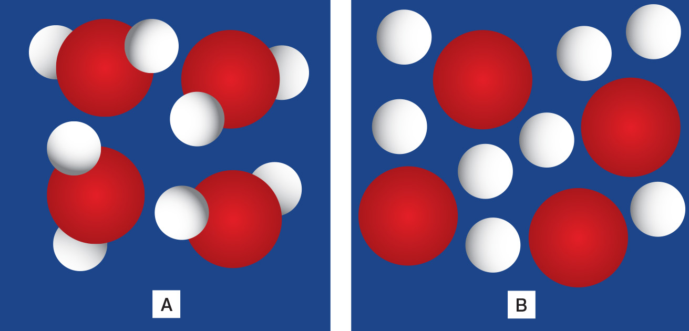

These diagrams show models of particles in different substances.
Which ones are pure substances?
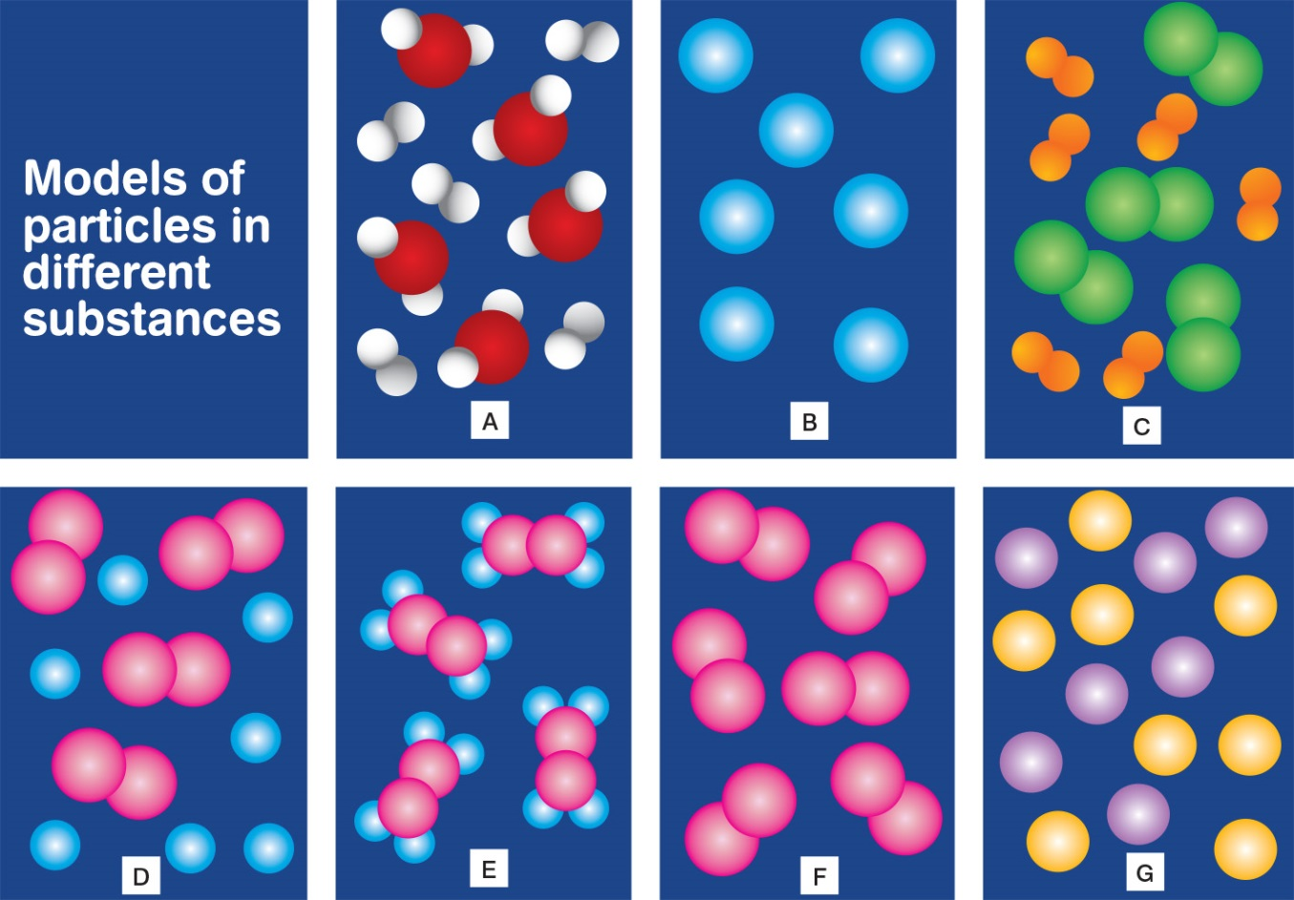

Are they elements, molecules, compounds or mixtures?
Substance A:

Substance B:
Substance C:
Substance D:

Substance E:

Substance F:
Substance G:

Activity 3.8 The periodic table

Notebook: Exploring the periodic table
1. Looking at the first two rows of the table describe how the elements change as you move from left to right across the table.
2. Focussing on columns 1, 2 and 13 to 18 describe what you notice about elements that are in the same column.
3. Why did Mendeleev decide to represent the elements in a table like this?

Activity 3.9 Iron – element, compound and mixture
Part A: Iron – an important element for life
What does haemoglobin do?
What is transpiration?
What do plants use chlorophyll for?
Part B: Iron – a compound
In your Notebook list the elements present in the different ores of iron.
Hematite –

Goethite –
Limonite –
Magnetite –
Part C: Iron - a mixture
Refer back to Activity 3.3 What are alloys?
What are the main uses of cast iron, stainless steel and wrought iron?

Which of these alloys contain iron mixed with one or more non-metals? Note which non-metals are used.

Lesson Outcomes Checklist Part 3
NAME:
ACTIVITY | LESSON OUTCOMES  At the end of these activities I can: | Please indicate if you achieved each learning outcome:  = Yes  ? = Partly  X = No
Activity 3.1 Is it pure or a mixture? | - identify some differences between a pure substance and a mixture.
Activity 3.2 Tiny particles | - describe techniques (evaporation, filtration, magnetism) used to separate materials.
Activity 3.3 What are alloys? | - identify different alloys and explain, using examples, why we use them.
 | - explain why alloys are mixtures.
Activity 3.4 Do the powders contain the same particles? | - name an element and its compounds.
 | - describe some chemical tests.
Activity 3.5 Splitting water | - describe how electricity can be used to split water into two gases.
Activity 3.6 Elements: the simplest substances | - explain that there are a limited number of elements and that each element is made from just one type of atom.
 | - understand that each element has its own symbol.
 | - understand that each element has its own unique name, which matches the name of its constituent atoms.
 | - classify elements into metals, non-metals and metalloids
 | - recognise that different elements melt at different temperatures.

ACTIVITY | LESSON OUTCOMES  At the end of these activities I can: | Please indicate if you achieved each learning outcome:  = Yes  ? = Partly  X = No
Activity 3.7 The purity of water | - identify that water is a compound; it is comprised of hydrogen and oxygen atoms always in the same proportion, which can be described using a chemical formula.
 | - identify the different patterns of atoms in elements, compounds and mixtures.
 | - recognise that both elements and compounds are classified as pure substances.
Activity 3.8 The periodic table | - explain why the elements are set out in a periodic table.
Activity 3.9 Iron – element, compound and mixture | - list some compounds and mixtures of iron.
Activity 3.10 Is it an element, compound or mixture? | - describe the differences between elements, compounds and mixtures, and identify examples of each.
 | - determine the name and number of elements in compounds.

Activity 4.1 Observing changes in water
Heating water
Record your results in the table.
Time (min) | Temperature (ºC) | Time (min) | Temperature (ºC)
0 |  | 16
1 |  | 17
2 |  | 18
3 |  | 19
4 |  | 20
5 |  | 21
6 |  | 22
7 |  | 23
8 |  | 24
9 |  | 25
10 |  | 26
11 |  | 27
12 |  | 28
13 |  | 29
14 |  | 30
15
Graph your results

Discussion
At what temperature did the water start to melt?
At what temperature did the water start to boil?
On your graph label when the water was a solid, liquid and gas.
Summary
Copy and complete the diagram in the Student Guide adding the name of the phase change on the arrows.
Think of another example to illustrate the following:
a) a solid changes to a liquid

b) a liquid changes to a gas
c) a gas changes to a liquid
d) a liquid changes to a solid

Notebook: Metals or non-metals
1. Having watched the States of Matter video, try to complete this table. CHECK your answers as you go.
 | Ice | Water | Water vapour
State
Volume
Shape
Temperature
Space between molecules
Arrangement of molecules
Speed of movement
Challenge Question
2. We know that ice floats on water, which is very unusual. Most materials sink when they become solid, but water is different. Check again how the water behaves as a solid and as a liquid. Can you explain why ice might float on liquid water?
Why is ice slippery?
3. Play the video to explore the behaviour of ice in a skating rink. Can you explain why skates seem to slide across the ice so easily?

Find out more: Ice: temperature and time
Record your notes here about the Find Out More if instructed by your teacher.

Activity 4.2 Ice play
Ice cream in a bag

Discussion
1. Explain why the ice cream froze in this recipe.
2. Why was the salt important?
Experiment: How does salt affect the freezing point of water?
My experimental method
My results

Activity 4.3 Can matter skip states?
Draw the phase changes of matter in your Notebooks.

Notebook: Can matter skip states?
Iodine
1. Describe the iodine gas. Is it heavier or lighter than air?
2. How much space does the iodine gas take?
3. Describe what happened to the iodine gas as it cooled.

4. What happened to the iodine gas as it cooled?
Dry ice
Watch the video of dry ice.
1. What is dry ice?
2. What happens when the dry ice is added to water?
3. What is inside the bubbles?

4. At the top of the cylinder a white mist forms. This is not carbon dioxide, which is invisible. What is it?

Moth balls
Moth balls are often made of a chemical called naphthalene. When moth balls are removed from the packet they sublime.
1. What are moth balls used for?

Activity 4.4 Detecting an invisible gas
Observations
Record your observations of what happened when you poured the large beaker onto the candle.

Discussion: How do we know that an invisible, odourless gas if really there?
1. What happened to the candle?
2. Referring to the chemical equation shown at right, explain why the candle behaved in this way.
3. Based on your observation do you think carbon dioxide is lighter or heavier than air?

Notebook: Invisible Gases
1. Which 3 gases account for 99% of the Earth’s atmosphere?
2. Which two gases are most vital for life on Earth?
3. Which gases appear to be the most toxic?
4. Which gas is essential to life but toxic in high concentrations?

Lesson Outcomes Checklist Part 4
NAME:
ACTIVITY | LESSON OUTCOMES  At the end of these activities I can: | Please indicate if you achieved each learning outcome:  = Yes  ? = Partly  X = No
Activity 4.1 Observing changes in water | - explain that substances can change state when they are heated or cooled.
 | - explain that a change in state does not produce a new chemical substance.
 | - interpret a graph documenting the change in temperature of water is it is heated and changes state.
Activity 4.2 Ice play | - explain how salt was used to lower the freezing point of water.
Activity 4.3 Can matter skip states? | - give examples and uses of sublimation.
Activity 4.4 Detecting an invisible gas. | - explain how carbon dioxide gas can be detected through its ability to smother a flame.
 | - identify a range of gases and describe their properties.
Activity 4.5 What is happening to me? | - describe what happens to particles when heated and cooled.
 | - use correct terminology for what takes place when matter changes state.

Activity 5.1 Some chemical changes
Record your results in the table
Test | Observations
1
2
3
4
5
Discussion
1. Chemical changes produce new substances. For each of these tests describe the observations that indicate that a new substance has been produced.
2. Chemical changes sometimes release large amounts of energy. Describe any of the reactions you observed where this occurred.

Activity 5.2 Observing reactions
Record your observations of each test in the table.
Test | Observations
1
2
3
4
5
Write a conclusion summarising what you have learnt in this activity.

Activity 5.3 Reactants and products
Write a definition of each term
Reactant:
Product:
Lead reaction
Copy the equation for this reaction and identify the reactants and products.
Equation:

Reactants:
Products:

Discussion: ‘Pop’ test
What gas was produced and why did it pop?
Do you know what the gas is?

Rewrite the equation for this reaction and identify the products and reactants.
For each of the following tests record your observations, write the equation and identify the reactants and products.
Test 1:
Test 2:
Test 3:

Activity 5.4 Some natural reactions

Notebook: Photosynthesis
A number of chemical reactions occur when plants make food during photosynthesis.
Sunlight helps the chemical reaction to occur.
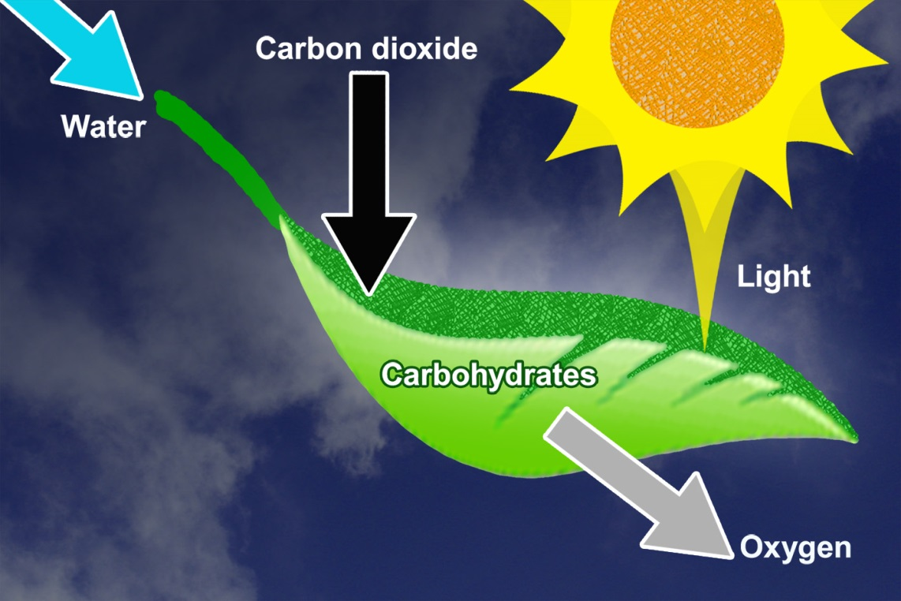
1. What are the reactants and products in photosynthesis?
2. Write the word equation for the chemical reaction.

3. Can you identify the individual elements in this natural reaction using the periodic table?

4. Explore the differences in plants located in the tropics to our colder regions in the southern states. What do you notice?

Notebook: Corrosion
Watch the video and then answer the following questions.
Corrosion is a chemical reaction that occurs in the presence of oxygen and water.
Rust is the corrosion of iron.
1. Write the word equation for the chemical reaction that forms rust.
2. What are the reactants and products for this reaction?
3. Can you identify the individual elements in this natural reaction using the periodic table?

4. Why do we use stainless steel? Watch the video to help you recall what you know about stainless steel and corrosion.

Activity 5.5 Investigating some useful reactions
Investigation 1: Make a rubber ball

Discussion
How high did your ball rebound when dropped from one metre?
How does the rubber ball differ in texture to the latex?
What could make your ball more “bouncy”?
Investigation 2: Make a synthetic rubber ball

Discussion
How well can your rubber ball bounce?

Is your rubber sticky?
Investigation 3: Make a resin (glue)

Discussion
How well did your glue stick?
How could you improve the stickiness of the glue? What fair test could you conduct to trial this?

Notebook: Discovering vulcanisation
Watch the video and answer the following questions.
1. Write the symbol for the chemical Charles accidentally added to the rubber.

2. Which famous company has taken its name from this scientist?
When scientists try to find answers to their questions, they follow a sequence of steps called the scientific method. These steps, in order, are in the left hand column.
3. In your e-Notebook, cut and paste the correct order of steps Charles Goodyear went through in discovering and testing usable rubber.
Scientific method |  | Correct order of steps |  | Charles Goodyear's steps
1. Making an observation. |  |  |  | Mixing sulphur with rubber will stop the rubber from going gummy when heated.
2. Asking a question. |  |  |  | The rubber with no sulphur went gummy while the rubber mixed with sulphur did not.
3. Forming an hypothesis. |  |  |  | This piece of rubber did not go gummy!
4. Carrying out an experiment to test the hypothesis. |  |  |  | Rubber mixed with sulphur does not go gummy when heated.
5. Analysing the results from the experiment. |  |  |  | I wonder if mixing sulphur with rubber stops the rubber going gummy when heated?
6. Forming a conclusion. |  |  |  | He mixed sulphur with a piece of rubber and then heated that piece in exactly the same way as another piece of rubber with no sulphur in it.

Activity 5.6 A rusty problem
Describe some places where you have seen rust.
What do rusty objects look like? What characteristic do they have in common?
Prediction: What do you think causes rusting?
Investigating rusting

Discussion
In which test tube(s) did the steel wool rust?

Was your prediction correct?
Katie, Joshua, Olivia and Iggy’s results
Test tube | Conditions | Observations
A | air only | no rusting
B | air and water | rusting
C | water only | no rusting
D | water and some air | some rusting

Discussion
How did your results compare to Katie, Joshua, Olivia and Iggy’s?
Based on the evidence you have seen, what causes rusting?

Extension
Now design an experiment to investigate the effect of salt on the corrosion of iron.

Activity 5.7 Preventing rust
Draw a sketch showing the treatment that was applied to each nail.
Observations
A:
B:
C:

D:
E:
F:
Discussion
• Was there any difference in the amount of corrosion (rusting) of each nail?

• Did the copper wire corrode?
• Did the magnesium ribbon corrode?
• What was the purpose of test-tube A?
• What is the name scientists give to test-tube A?

• Iron is a cheap and strong metal but it is very reactive. There are many different methods we can use to prevent iron from rusting. What methods have you found?
• Where would you expect iron to rust fastest, in a river or an ocean? Explain your answer.
• What would be the best form(s) of rust protection for cars parked in seaside suburbs?

Activity 5.8 Do other metals corrode like iron?
My investigation
(Describe your methods, results and conclusions). Your research question is the one provided above.

Activity 5.9 Chemical hazards

Notebook: Prepared for particles
Watch the four videos and describe one of the hazards described and what safety practices help workers avoid that hazard.
Why do we need safety rules and practices in the laboratory and workplace?

Lesson Outcomes Checklist Part 5
NAME:
ACTIVITY | LESSON OUTCOMES  At the end of these activities I can: | Please indicate if you achieved each learning outcome:  = Yes  ? = Partly  X = No
Activity 5.1 Some chemical changes | - describe a range of observable changes that occur during chemical reactions.
Activity 5.2 Observing reactions | - describe a range of observations that provide evidence for chemical changes.
Activity 5.3 Reactants and products | - identify the reactants and products in a chemical reaction.
 | - write the word equations for chemical reactions.
Activity 5.4 Some natural reactions | - identify some naturally occurring reactions.
 | - explain why photosynthesis is one of the most significant chemical reactions.
Activity 5.5 Investigating some useful reactions | - give an example of a useful reaction and describe the properties that make it so.
Activity 5.6 A rusty problem | - define rust and what causes it.
Activity 5.7 Preventing rust | - describe some methods of preventing corrosion of iron.
Activity 5.8 Do other metals corrode like iron? | - demonstrate their ability to design and conduct an investigation to answer a question.

Activity 5.9 Chemical hazards | - describe some safety precautions required when in danger of being exposed to hazardous particles in the air.

Acknowledgements
Science by Doing is supported by the Australian Government Department of Education, Skills and Employment. The views expressed here are those of the author and do not necessarily represent the views of the Australian Government Department of Education, Skills and Employment.
Copyright
© Australian Academy of Science, 2021
Rock, Paper, Scissors, Student e-Notebook: ISBN 978-0-85847-795-7
Published by the Australian Academy of Science
GPO Box 783
Canberra ACT 2601
Telephone: 02 6201 9400
www.science.org.au

The details of the relevant licence conditions are available on the Creative Commons website (accessible using the links provided) as is the full legal code for the Creative Commons Attribution-NonCommercial-ShareAlike 4.0 International (CC BY-NC-SA 4.0) licence (https://creativecommons.org/licenses/by-nc-sa/4.0/legalcode).
Click here for a full version of unit acknowledgements and sources or logon to www.sciencebydoing.edu.au.
Last revised: 29 October 2021

